BUILDING AND PUBLISHING
POWER BI REPORTS
INTRODUCTION
Power BI is a powerful business tool that lets users connect to different data sources, change raw data, and create interactive visuals for valuable insights. In this project, we designed and delivered a Power BI report that encompasses the entire workflow and facilitates business performance assessments across three perspectives: Overview, Customer Analysis and Product & Time Analysis.
The Overview page presents important figures of Total Sales, Total Quantity, and Customer Count with graphics, including a demographic representation (age, gender). The Customer Analysis page analyzes customer behavior with tables, formatting, and scatter plots, including clustering to help identify high- and low-value customers by page or quantity spent. The Product & Time Analysis page summarizes product performance with a line, column, and donut charts to show monthly sales by product and contribution by product category.
The report enhances interactivity with synced slicers across pages, drill-throughs, and navigation buttons to dynamically explore the data. The report was published in the Power BI Service to provide accessibility for collaboration and real-time decision-making.
AIM
To create an interactive Power BI report that turns raw sales and customer data into useful insights and publish the report to the Power BI Service for collaboration.
OBJECTIVE
- To design three report pages - Overview, Customer Analysis, and Product & Time Analysis.

- To utilize visualizations (cards, charts, tables and slicers) to present data in an easy to consume format.

- To enable slicer synchronization, drill-through and bookmarks to enable interactivity and navigation.

- To publish the report on Power BI Service to make the report accessible for sharing and collaboration.
WHAT ARE REPORTS
A Power BI report is a collection of one or more pages containing visuals that represent data from a dataset. Power BI report is an interactive data visualization that is created in Microsoft Power BI Desktop or in the Power BI Service. You can visualize your raw data in Power BI reports. They are intended to help you convert raw data into actionable insights, through different types of data visualizations (charts, tables, maps, KPIs, etc).
Key Features of Reports:
- Reports can have multiple pages.
- It uses interactive visuals like clicking on one visual, filters the others.
- These report supports advanced features such as drill-downs, tooltips, and cross-filtering.
- Reports can connect to many types of data sources (Excel, SQL, cloud services, APIs, etc.).

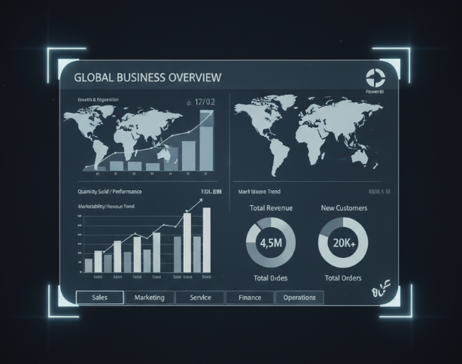
Source: Created by Gemini AI

LEARNING OUTCOMES
- Understand Power BI Reports
- Design Interactive Reports
- Use Visualizations Effectively
- Analyze Data and gain insights
- Publish and Share Reports

PRE-REQUISITE SETUP
Before starting, ensure the following setup is ready:
- Software Requirements
- Power BI Desktop installed (latest version recommended).
  - Have access to the Power BI Service (account required for publishing).
- Data Requirements
  - Prepare datasets (e.g., Fact_Sales, Calendar table, Customer data, Product categories) and ensure data is cleaned and structured for analysis.
- User Account
  - Create or use an existing Power BI account (organizational or personal) for publishing.
  - Sign in to Power BI Desktop with your account.
- Knowledge Requirements
  - Basic knowledge of data analysis (sales, customers, products).
  - Basic understanding of visualization concepts (charts, tables, slicers).
- Connectivity & Access
  - Stable internet connection for publishing and accessing Power BI Service.

IMPLEMENTATION STEPS
      - Design Report Pages
Page A - Overview
- In Power BI desktop, at the bottom, right-click on Page 1 and select Rename and enter Overview.
- Now, we will create cards for Total Sales, Total Quantity and Distinct Customers. Insert Multi-row Card visual from visualizations which is shown below.
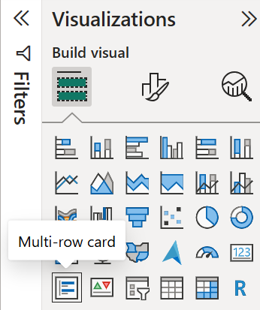
- Drag Total Sales, Total Quantity measure and CustomerID column into the Fields well. Then, right-click on CustomerID in Fields well and select Count(Distinct).
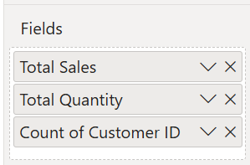
- In Format visual, In the Callout values section, increase the font size property to 28pt. In the General tab, in the Effects section, set the background color property to a light gray color (such as White, 10% Darker) to provide contrast.
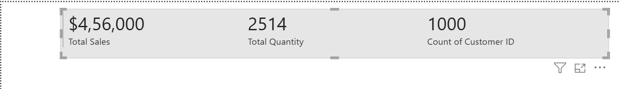
- In Data pane, select Total Sales and change its format as Currency.
- In the Visualization pane, select a Line chart and set X-axis to MonthYear from Calendar table and Y-axis to Total Sales from Fact_Sales table.

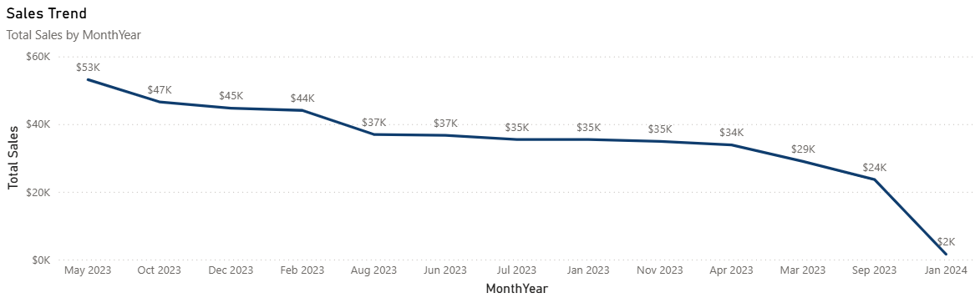
 Note: This line chart shows how sales changed over the time(month). Highest point denotes the highest sales in that particular time period.
- Now, select a Clustered bar chart from the visualization pane and set X-axis to Total Sales and Y-axis to Product Category from Fact_Sales table.
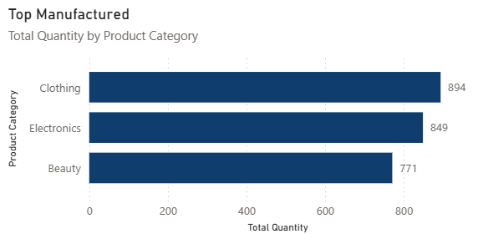
 Note: This bar chart shows about the Manufacturing of each Product Category. The amount of manufactured product has been mentioned using data labels.

- Select a Clustered column chart from the visualization pane and set X-axis to Product Category and Y-axis to Total Quantity from Fact_Sales table and add Gender to Legend well.
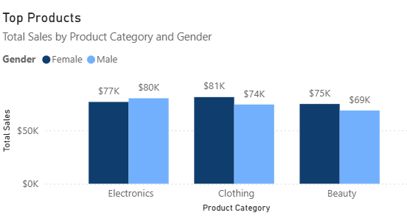
 Note: This column chart indicates the top sold products using Total Sales value. It shows which Product category is bought more by men and women.
- Now, let us add slicers to the visual. Select a slicer visual from the visualization pane and set its Field to Year from Calendar table. In Format tab, under slicer settings set the style to vertical list. Do the same for Product Category, Age and Gender slicer.

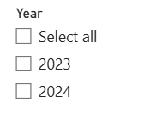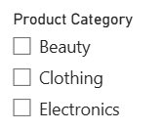
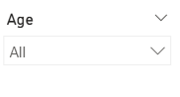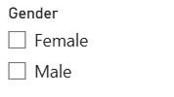
 Note: Slicers make the report interactive by adding filters to the visuals. Using the slicers we can gather the details from the visuals by applying any of these slicers.
- In Insert ribbon, inside Elements click on Image and select the image from the folder and place it in the visual.

Page B - Customer Analysis
- In Power BI desktop, at the bottom, right-click on Page 2 and select Rename and enter Customer Analysis.
- Now, we will create a Customer Table by inserting a table visual with CustomerID, Age, Gender, Total Sales, Total Quantity as the fields which show the customer wise Total Sales.
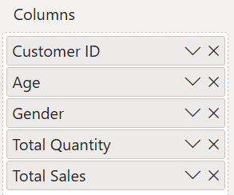
- Then, add conditional formatting to the Total Sales column in the table visual. Right-click on Total Sales column and select conditional formatting followed by Icons.
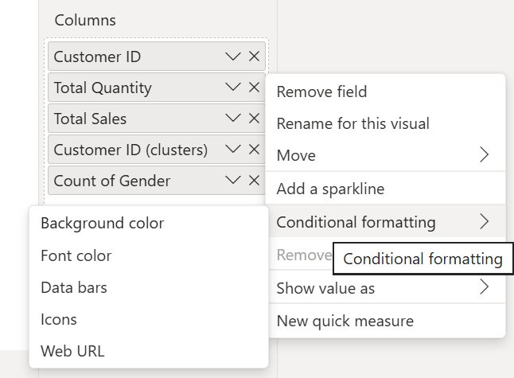
- Enter conditions showing that if the Sales value is equal to or greater than 1000, it will be marked with a green flag. Else it will be marked with a red flag.
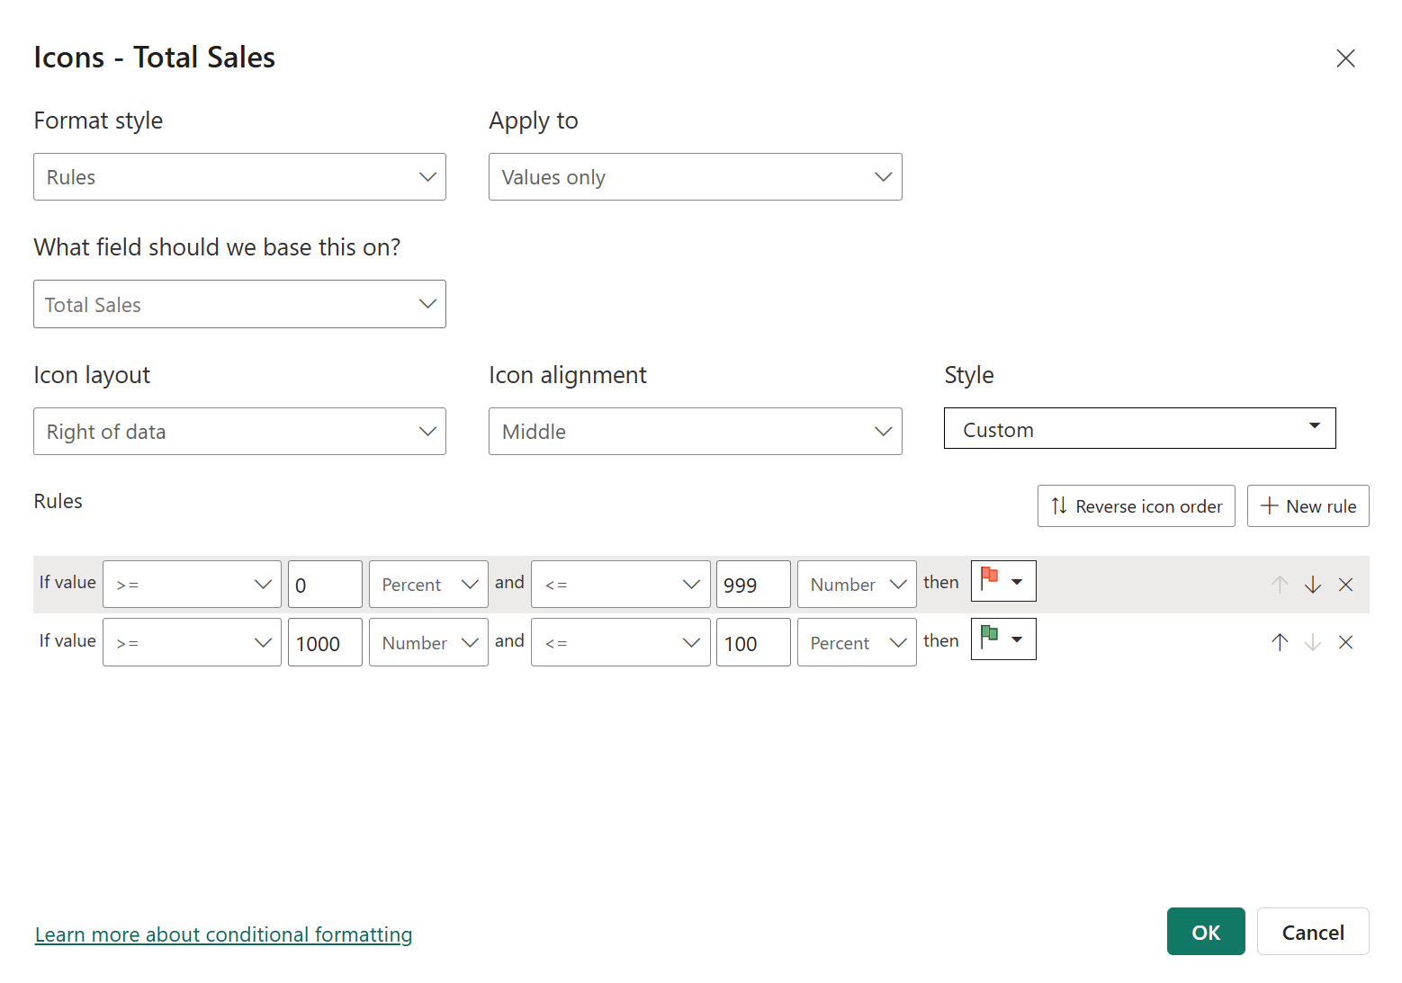

 Note: Conditional formatting lets us change colors, icons, or bars based on a condition or value. This helps highlight the data and insights.

- Now, the table visual looks like below.
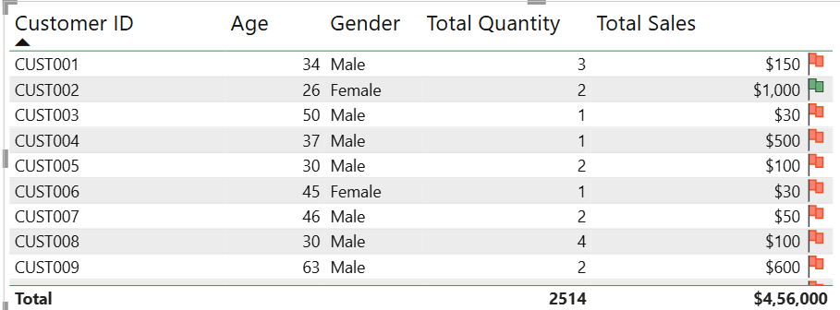
- Let us add a scatter chart that denotes the customer behavior. Drag Total Sales at Y-axis, Total Quantity measure at X-axis and CustomerID column at values in the Fields well.

- Then, right-click on CustomerID in Fields well and select Automatically find clusters. Now, drag this CustomerID Cluster into the legend.

- In format visual, set the legend, zoom slider and category label On.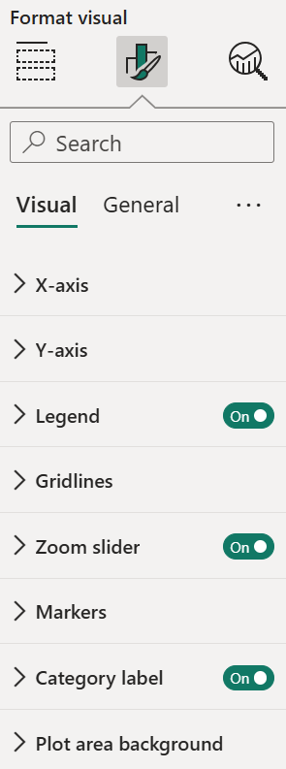

- The scatter chart looks like below.
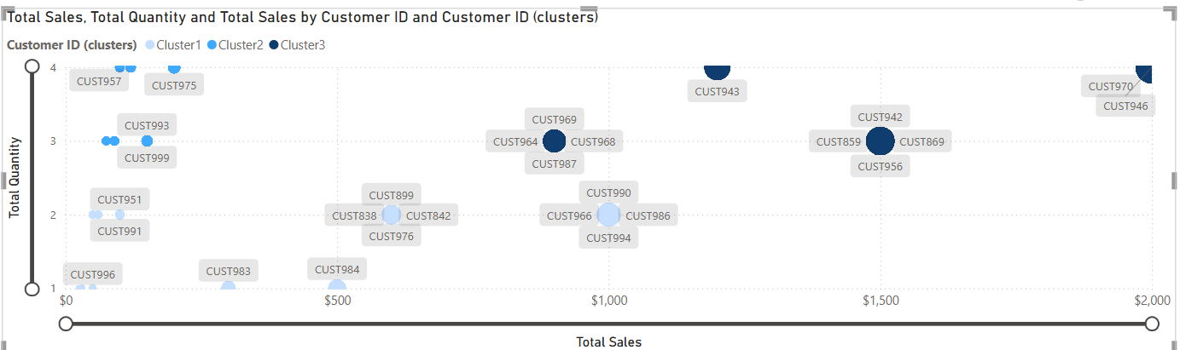
 Note: The plotted data reveal customers grouped into three clusters based on total sales and quantity purchased. It also provides further patterns of interest, such as high-value customers, who have made large purchases, and low-value customers with smaller purchases, to facilitate your strategy.
- Add Year slicer and Gender slicer to the visual.
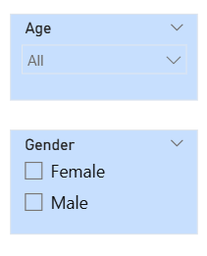

- Now, add newly appeared CustomerID Cluster column from Data Pane to the Table visual’s field well. Now the table visual looks like below.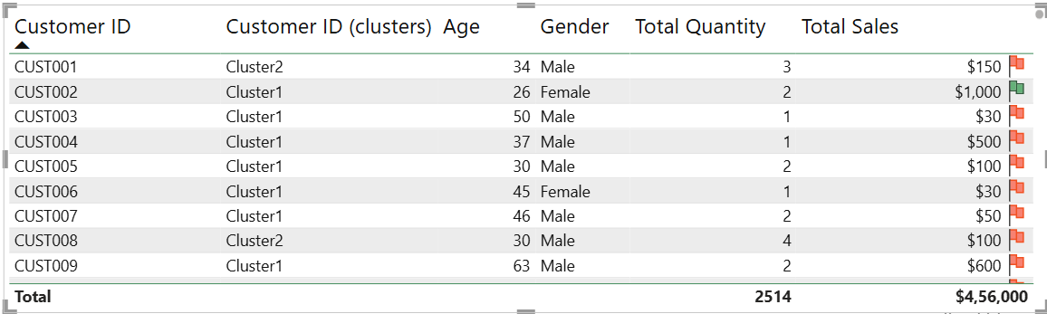

Page C - Product & Time Analysis
- In Power BI desktop, at the bottom, right-click on Page 3 and select Rename and enter Product & Time Analysis.
- Insert a Line and Clustered column chart to show to Monthly Sales Trend according to Product category and Total Sales.
- Drag and drop the columns into field well as mentioned below.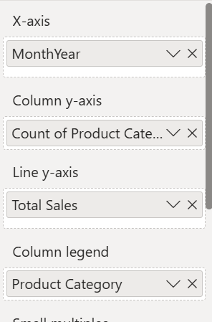

- In the Format Visual, turn on the legend and data labels. Then, in columns dropdown change each Product category column’s color into a suitable one.
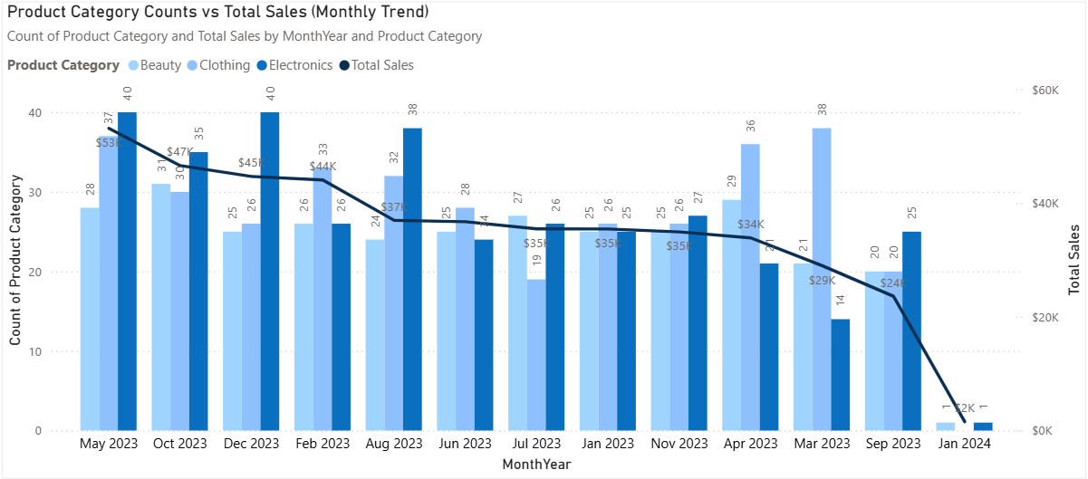
 Note: This chart shows the Monthly Trend based on Count of Product Category and Total Sales. The column chart denotes the quantity of each product manufactured and line chart shows the Total Sales on that specific time period.

- Now, add Year and Product Category slicers to the visual.
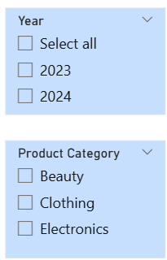

- Now, add a Donut chart to represent about the Total Sales by each Product Category.
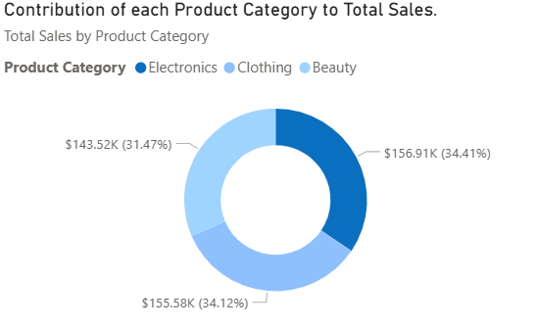
 Note: It shows the amount that each product category contributes to the Total Sales.
- Add a Table visual and then drag MonthYear, Product Category, Total Quantity and Total Sales into the fields well which denotes the details about Product Category, its quantity and sales.
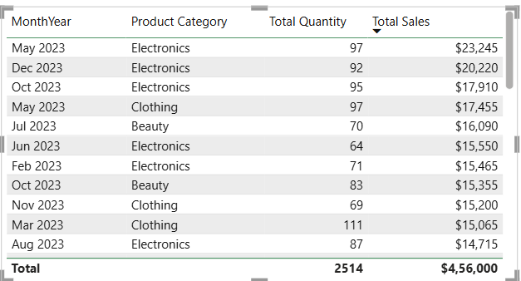

      - Sync Slicers in all three pages

- In the View ribbon, from the Show panes select Sync Slicers.
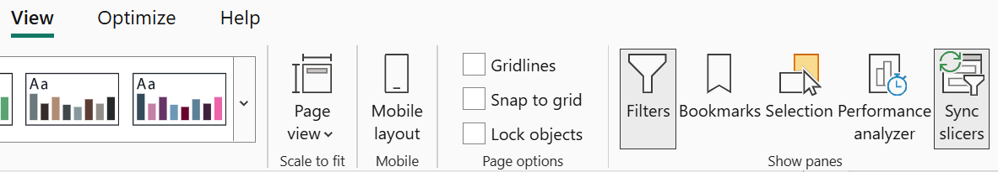

- Select the Year slicer from Overview page. Expand the sync slicer pane.
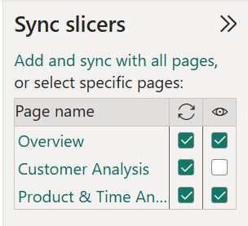
Note: The first circular arrow denotes the pages which the slicer needs to be synced and the second eye option denotes the pages which the slicer needs to be visible.
- Select the pages to sync year slicer and pages the year slicer to be visible.
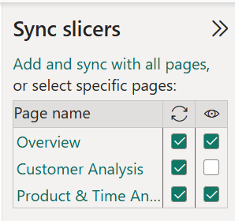
 Note: Year slicer will be visible in first and third page and it will be synced in all the pages.
- Follow the same procedure to sync all the slicer from the Overview page to other two pages.
Important: Make sure to sync the slicers to all the pages to view the result of slicer in all the report pages.

  - Product Category slicer
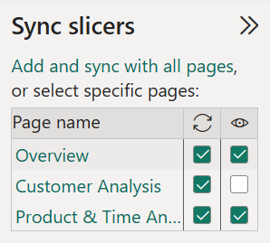
 Note: Product Category slicer will be visible in first and third page and it will be synced in all the pages.
  - Age slicer
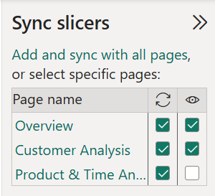
 Note: Age slicer will be visible in first and second page and it will be synced in all the pages.
  - Gender slicer
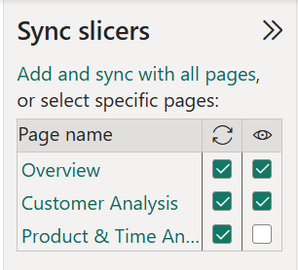
 Note: Gender slicer will be visible in first and second page and it will be synced in all the pages.

      - Create Drill-throughs

- In the Visualizations Pane of Customer Analysis page, scroll down and notice the drill-through well. Add Gender and Product Category to the drill-through well.
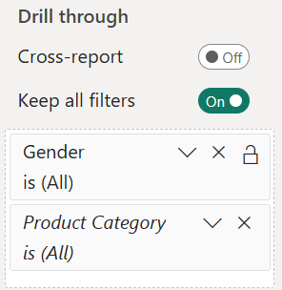

- Go to Product and Time Analysis page, and add Product Category to the drill-through well.

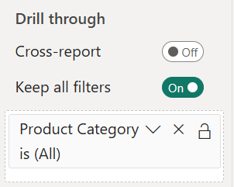
- Now, we shall check the working of drill-through. Go to the Overview page, in the Top Products chart right-click on any column and select drill-through and any page name.
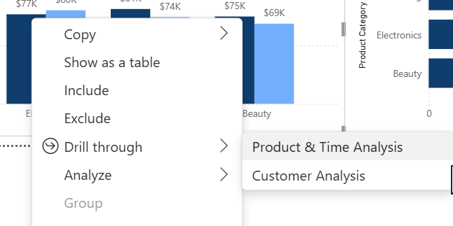

- Now you will notice the changes in visuals of Product and Time Analysis page and in drill-through field you will notice the filters that are applied to visual through this drill-through.
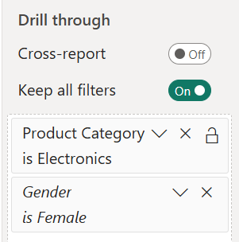
  - Publish to Power BI Service

- In Home ribbon, select Publish from Share group.
 Important: To publish your work to Power BI service, sign in is required. So, make sure to sign in and save you work before publishing.
- Select the workspace you need to Publish, then it will load and notify you once its published.
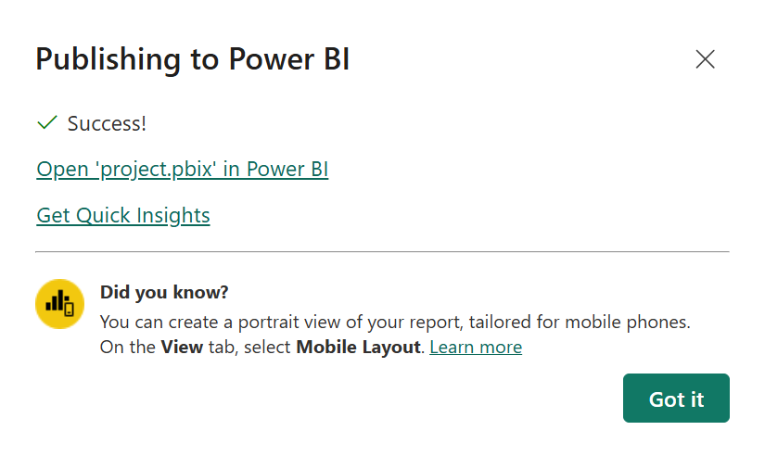

- Go to the Power BI service and check the workspace where you published your work, the report and semantic model will appear in your workspace.
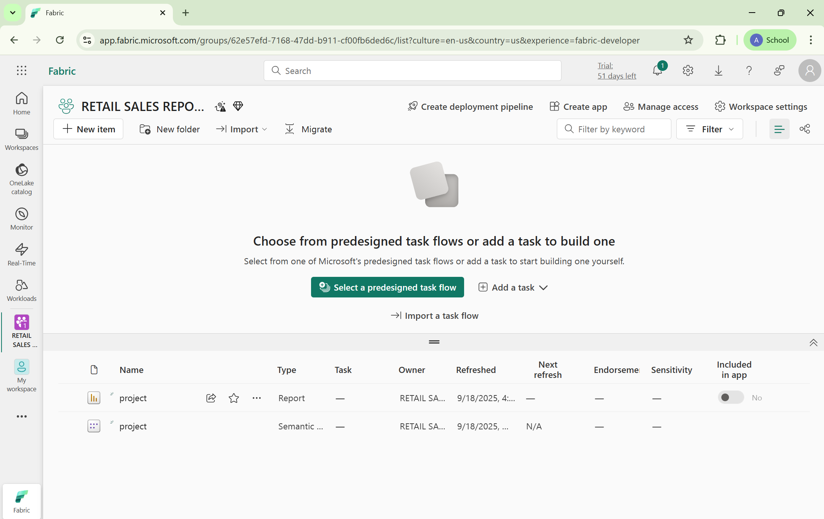

- Click on report and your report will be displayed. Select and view your report.
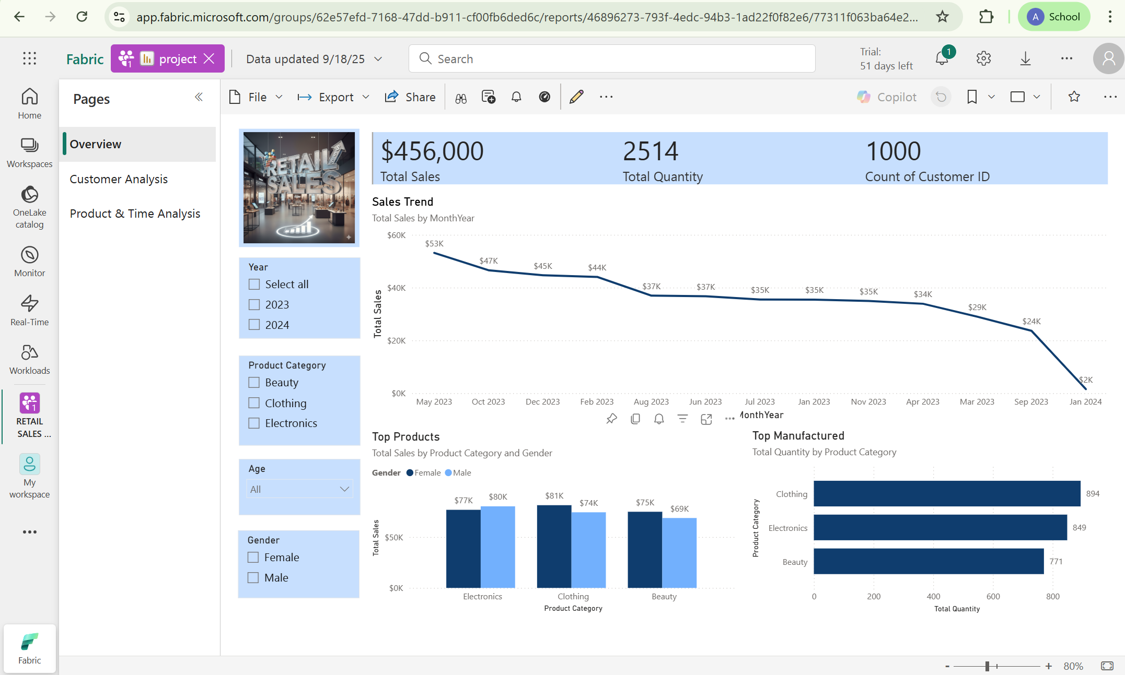

- On the Pages pane, the report pages will be displayed where you can select the page and view the page contents.
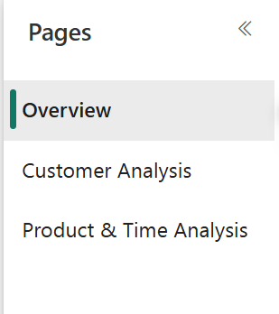

RESULT

Page A – Overview
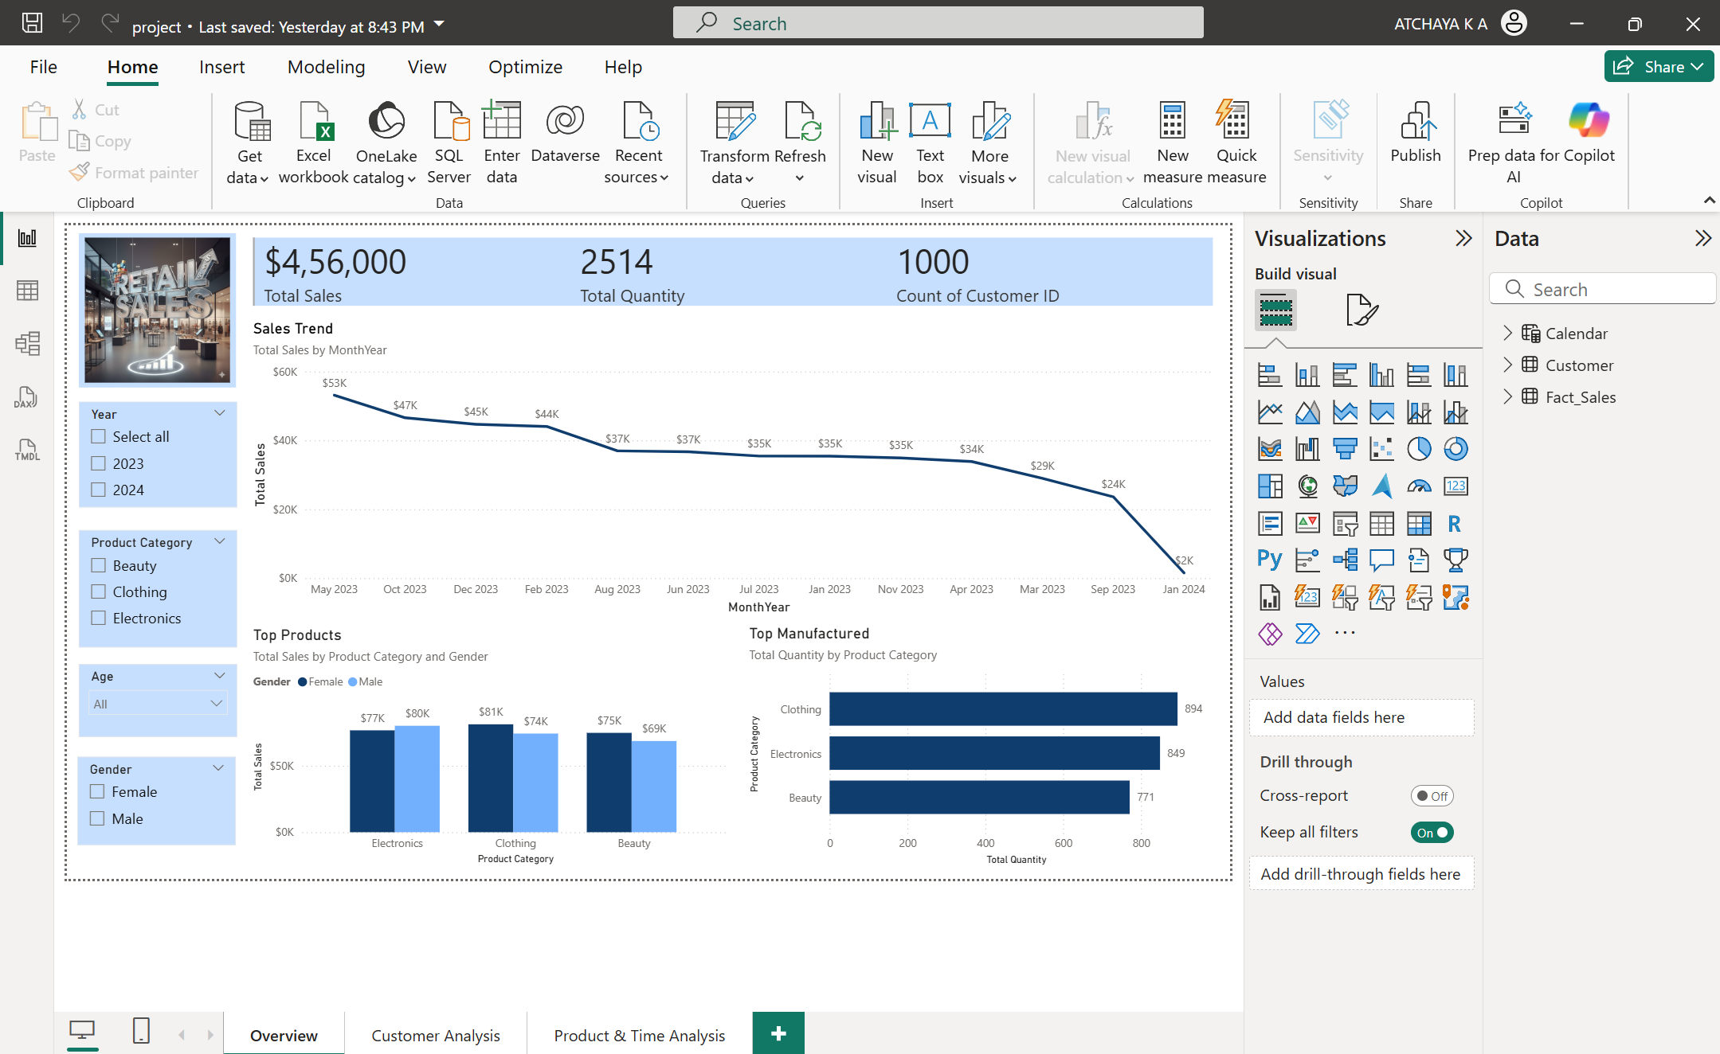
Page B - Customer Analysis
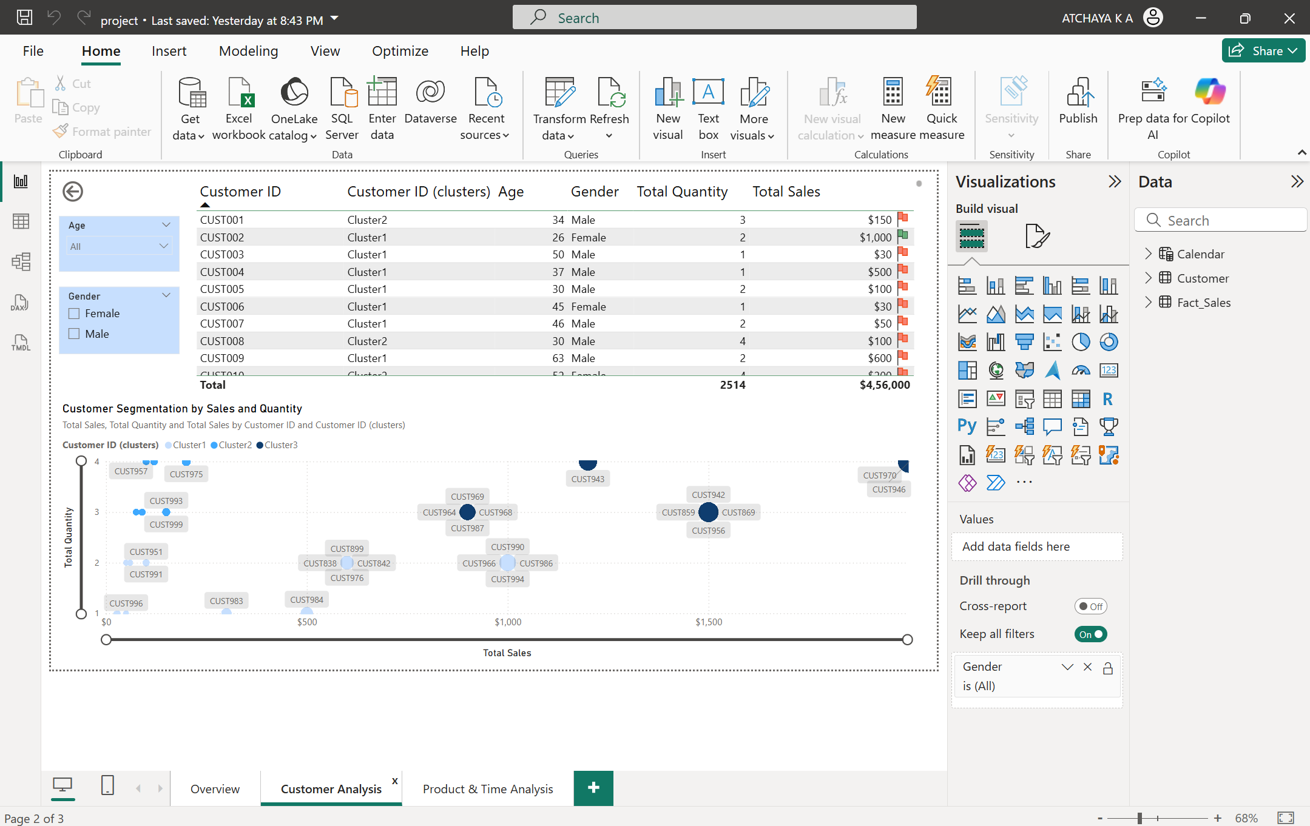
Page C - Product & Time Analysis
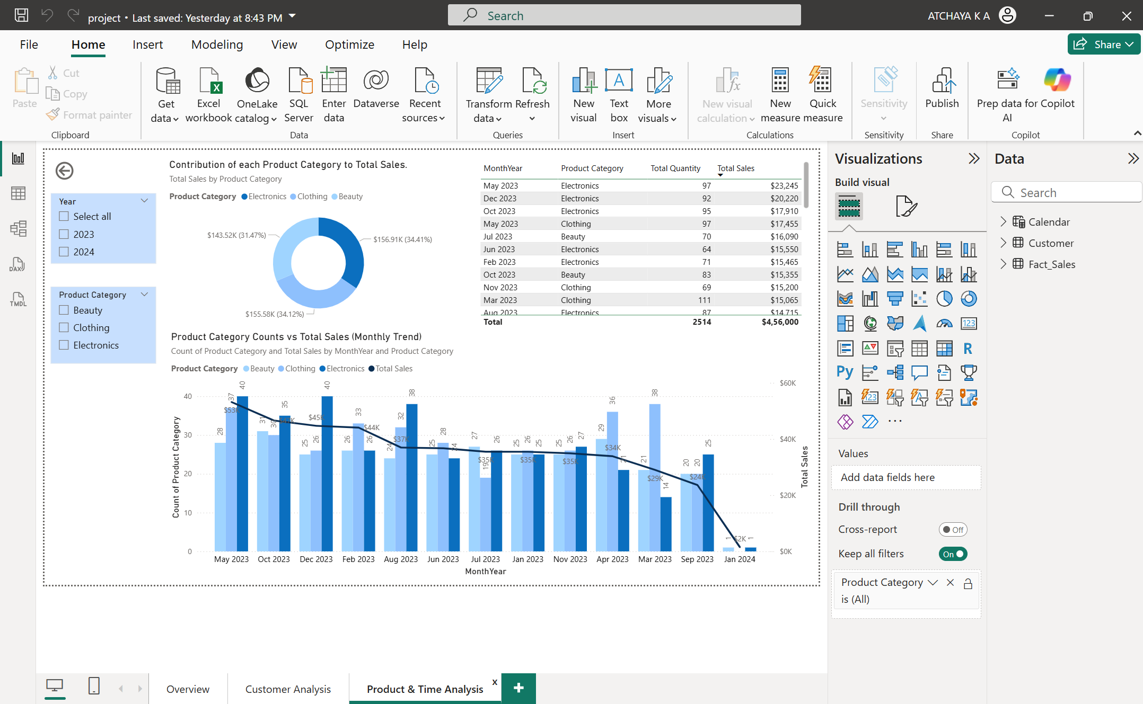
Published Report on Power BI Service
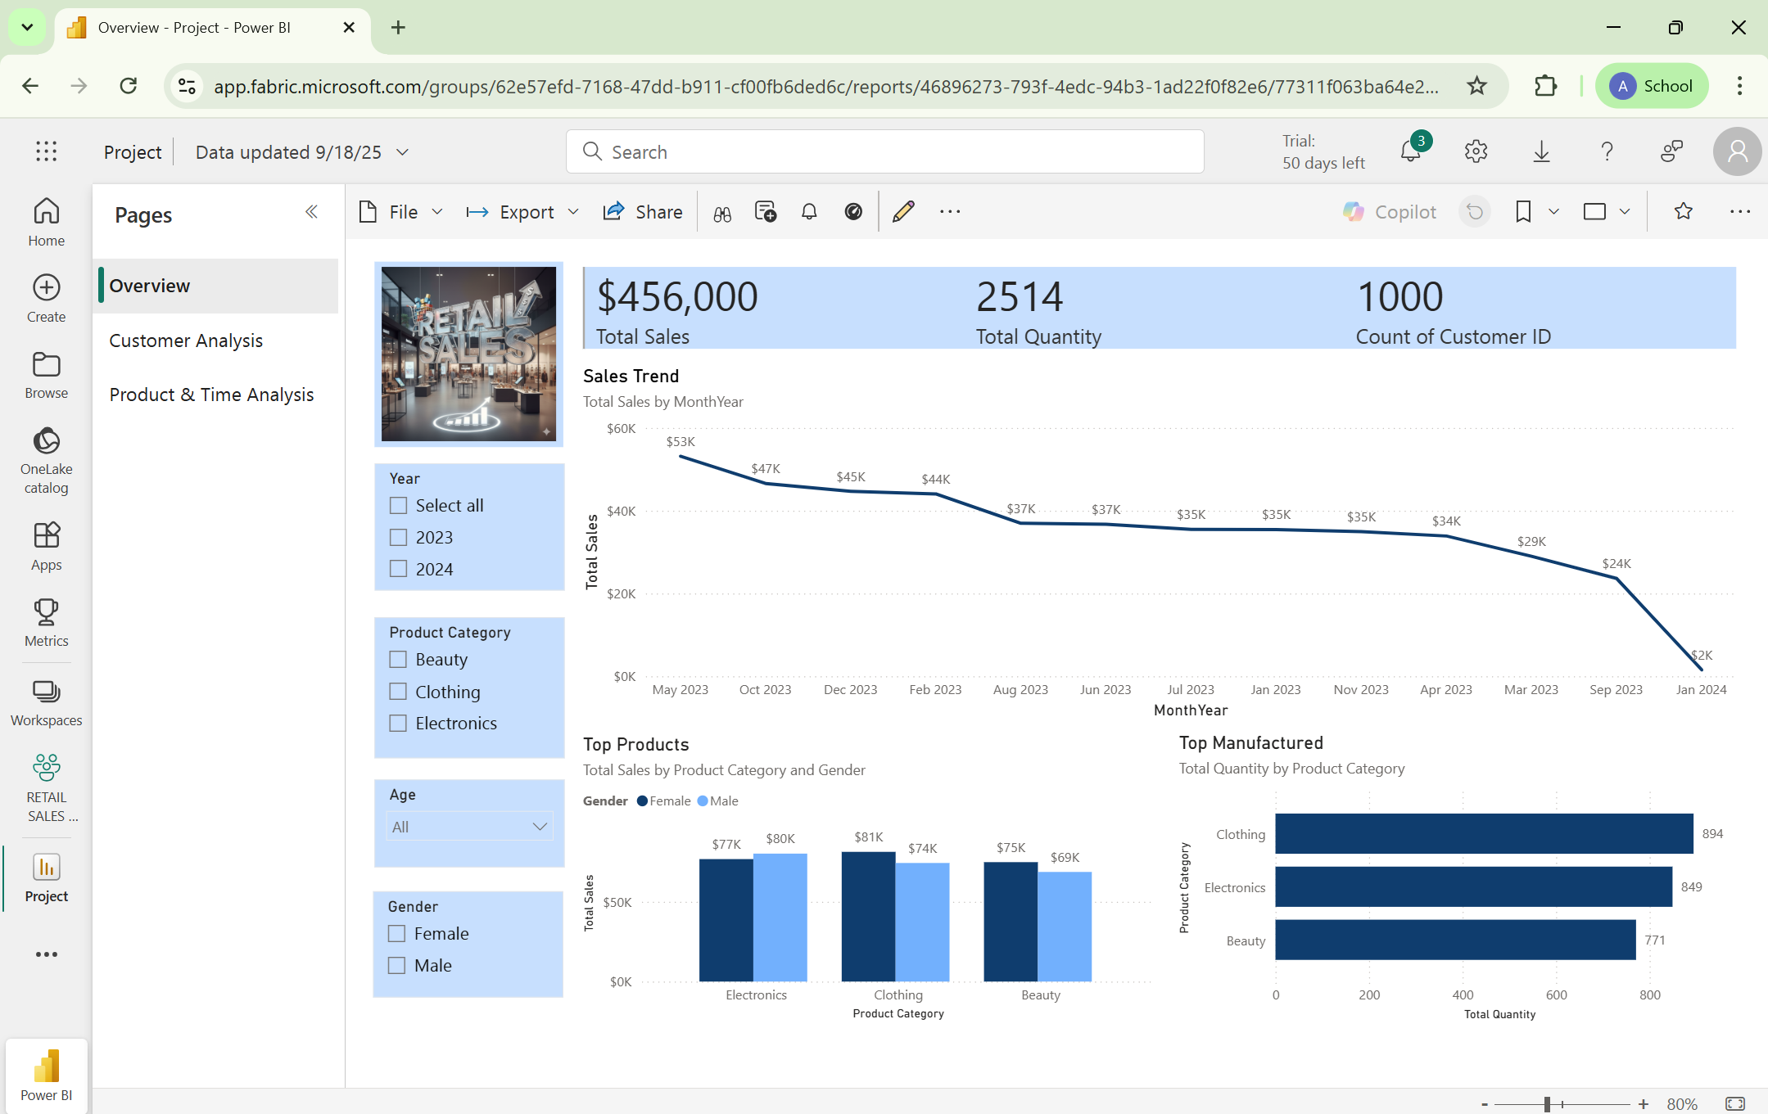
https://app.fabric.microsoft.com/links/RZG3JrRcVb?ctid=7b8d4885-765a-4299-9a92-4edb30779085&pbi_source=linkShare
CHALLENGES
      - Raw sales and customer data may contain missing values, duplicates, or inconsistencies that affect report accuracy.
      - Managing slicers across multiple pages requires careful syncing and incorrect settings may lead to misleading results.
      - Understanding concepts like clustering may be confusing and complicated.
      - Some features, such as drill-through, bookmarks, and conditional formatting, can be hard to implement without practice.
      - Users may experience sign-in problems, restricted access to workspaces, and inability to share reports in the services of Power BI.
RECOMMENDATIONS
      - When working with data, it's best to do the data profiling and cleaning within Power Query and maintain a structured data model built with fact and dimension tables for performance and clarity.
      - Too much on a page can be overwhelming for some clients or users, and is overwhelming for users and simply not necessary.
      - Decide on Slicers that you want to sync across pages early on in the project.
      - Test and validate all calculations, filters, and visuals within Power BI Desktop prior to publishing to the Service.
SUMMARY
This project illustrated the development and publication of an interactive Power BI report that sources analytics on sales and customer data from multiple viewpoints. The report was constructed with three report pages i.e Overview, Customer Analysis, and Product & Time Analysis, to capture a full analysis of overall performance, customer behavior, and product trends. The report leverages a variety of visuals in an effort to create relevant business insights from a raw dataset, such as cards, charts and tables, slicers, scatter plots, and donut charts. Interactivity of the report was enabled by synchronized slicers, drill-throughs, and conditional formatting in order to enhance the dynamic experience and user satisfaction. In the end the report functionality was published to the Power BI Service in order to provide usability, collaboration, and data driven decisions. Throughout the challenges faced during the project, such as data quality, model complexity, and performance optimization, this project will assume its place providing business insights in the Power BI platform, but also documentation establishing Power BI as a viable option for obtaining business intelligence results out of data.

AI TOOLS USED
- Gemini AI: Generate images
- ChatGPT: Generate and verify the DAX queries and understanding clustering process
REFERENCES
- For further learning, refer
  - Design Power BI reports
  - Enhance Power BI report designs for the user experience
  - Perform analytics in Power BI

- Skillable Labs: Microsoft Skillable Labs

- Microsoft resources:
Create reports and dashboards in Power BI - Power BI | Microsoft Learn
Collaborate and share in Power BI - Power BI | Microsoft Learn

- Microsoft Learn Video Tutorials: Power BI Tutorials

